Test Case: tc003_SPX_Dev5_Crear_Requisicion_Spot_Tipo_Cobro_CC_Urgent
Step 1 - Enter username and password and click to button Enter : Credentials Entered
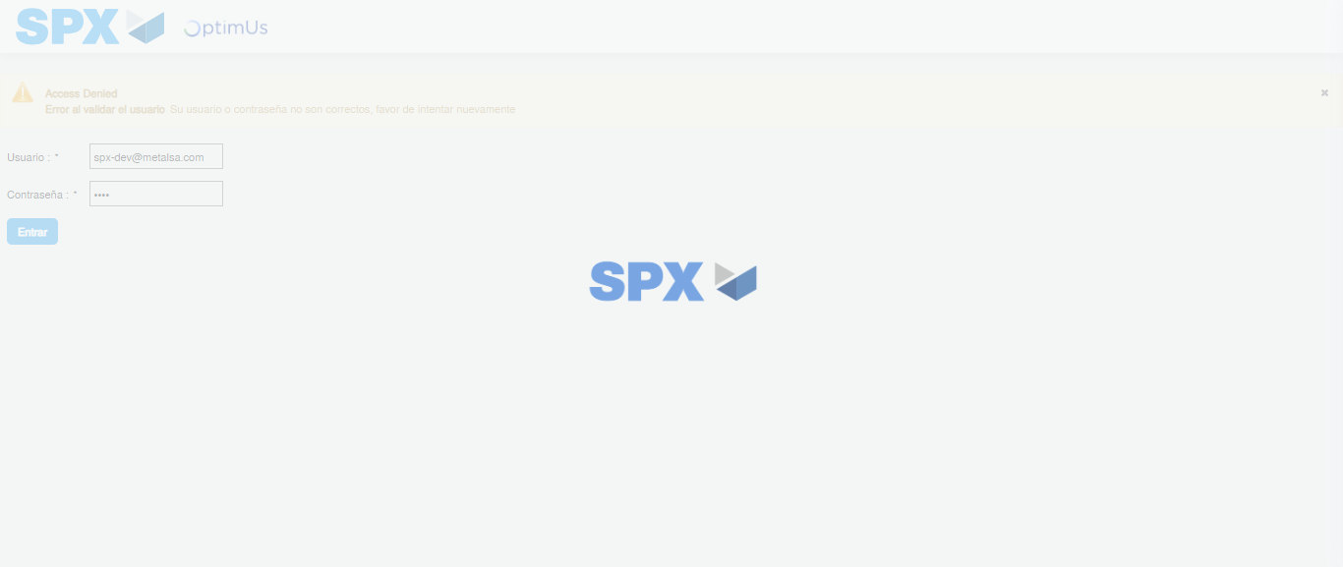Image file-name: QC_Testing-tc003_SPX_Dev5_Crear_Requisicion_Spot_Tipo_Cobro_CC_Urgent-1785961121569

Step 2 - Select to UEN and Access to Spot Buy Requisitions : UEN Correctly selected and Correct access
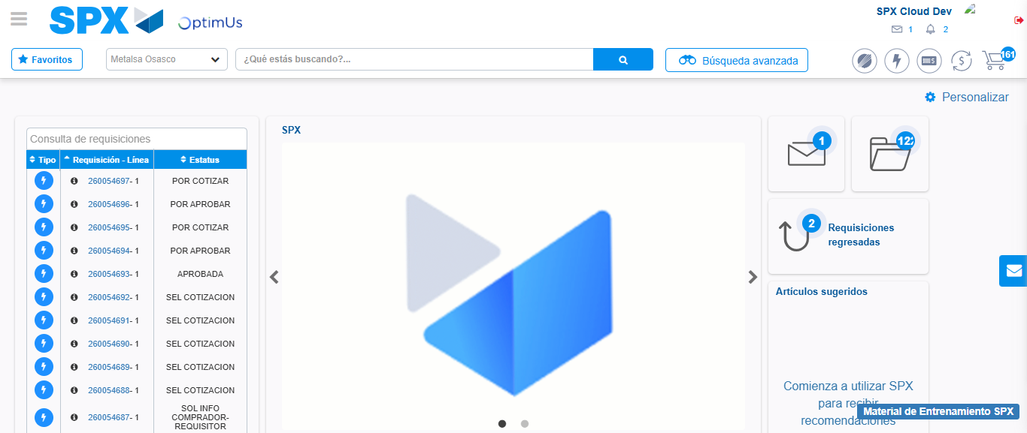Image file-name: QC_Testing-tc003_SPX_Dev5_Crear_Requisicion_Spot_Tipo_Cobro_CC_Urgent-1785961149324

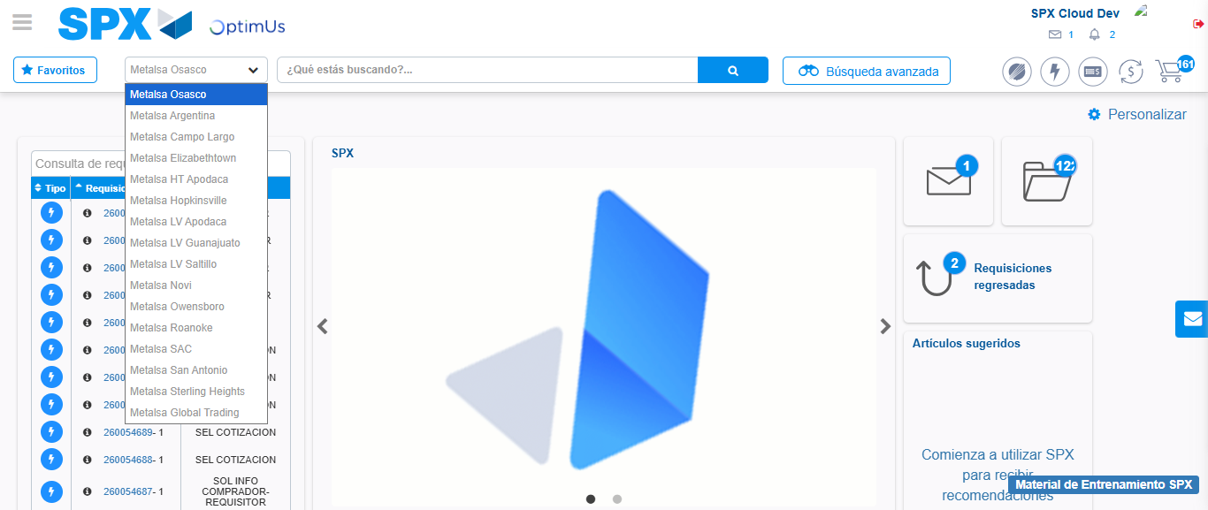Image file-name: QC_Testing-tc003_SPX_Dev5_Crear_Requisicion_Spot_Tipo_Cobro_CC_Urgent-1785961152032

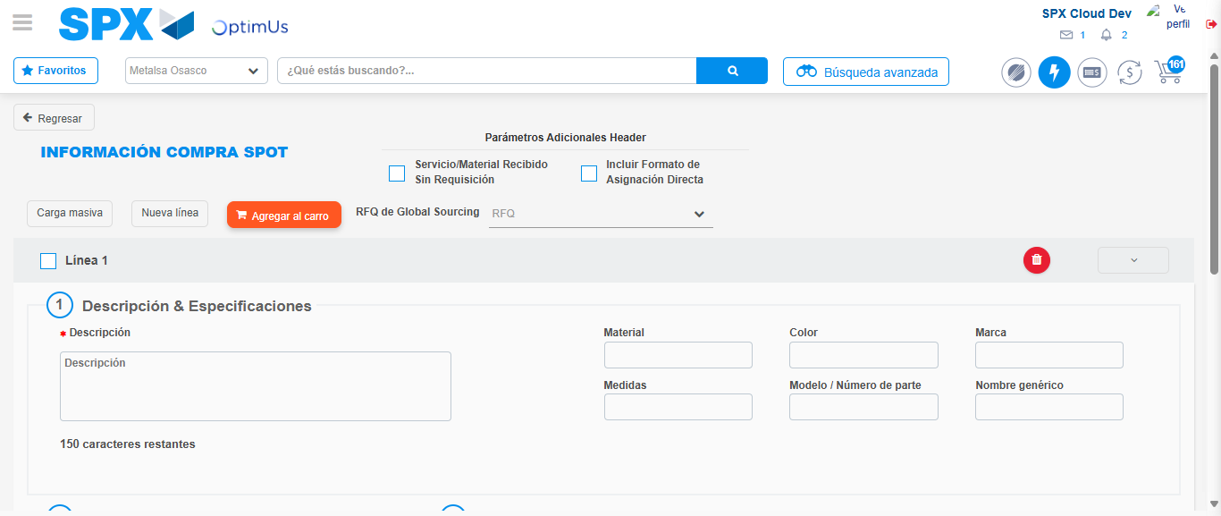Image file-name: QC_Testing-tc003_SPX_Dev5_Crear_Requisicion_Spot_Tipo_Cobro_CC_Urgent-1785961164318

Step 3 - Data Capture Spot Buy Requisition: Data captured correctly
Image file-name: QC_Testing-tc003_SPX_Dev5_Crear_Requisicion_Spot_Tipo_Cobro_CC_Urgent-1785961164583

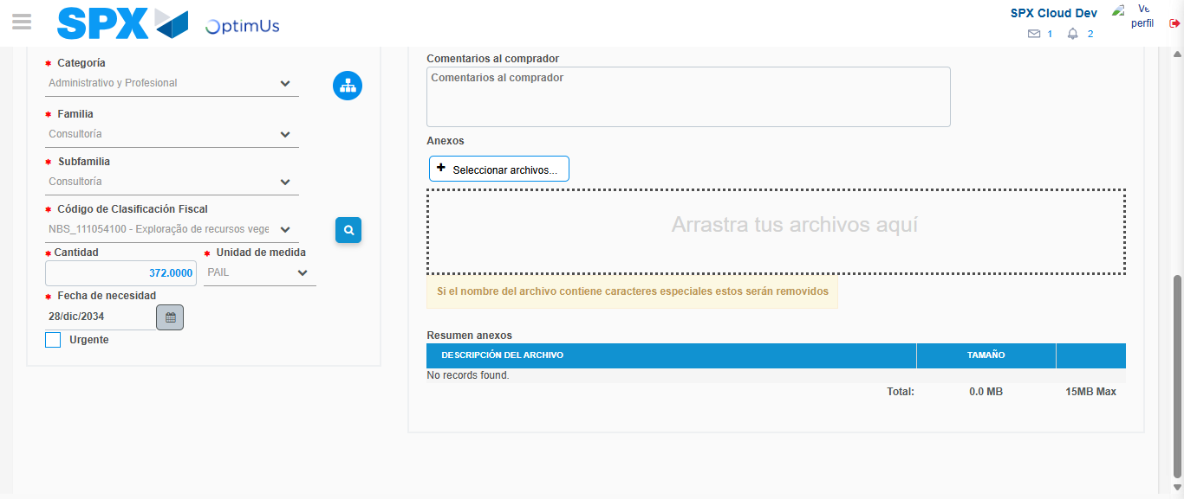Image file-name: QC_Testing-tc003_SPX_Dev5_Crear_Requisicion_Spot_Tipo_Cobro_CC_Urgent-1785961180677

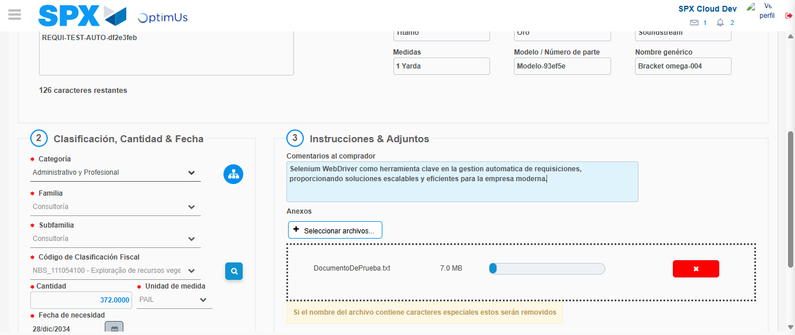Image file-name: QC_Testing-tc003_SPX_Dev5_Crear_Requisicion_Spot_Tipo_Cobro_CC_Urgent-1785961181437

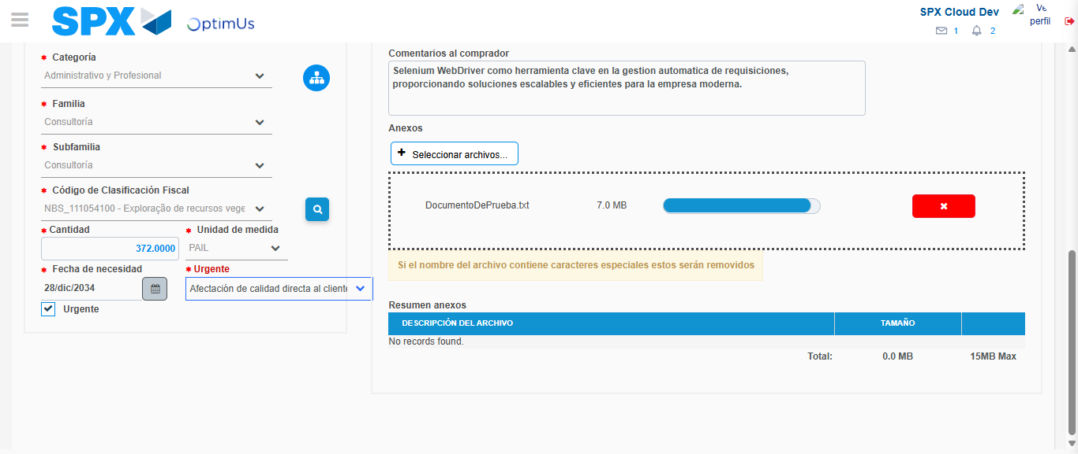Image file-name: QC_Testing-tc003_SPX_Dev5_Crear_Requisicion_Spot_Tipo_Cobro_CC_Urgent-1785961185094

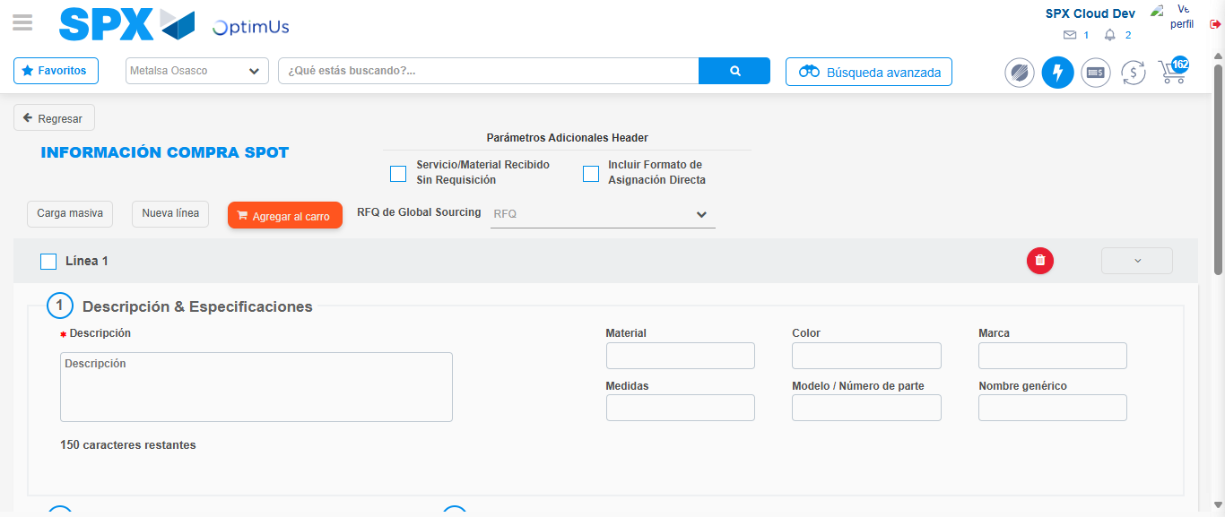Image file-name: QC_Testing-tc003_SPX_Dev5_Crear_Requisicion_Spot_Tipo_Cobro_CC_Urgent-1785961196361

Step 7 - Return to Main Page SPX : Return to Main Page SPX
Image file-name: QC_Testing-tc003_SPX_Dev5_Crear_Requisicion_Spot_Tipo_Cobro_CC_Urgent-1785961149324

Image file-name: QC_Testing-tc003_SPX_Dev5_Crear_Requisicion_Spot_Tipo_Cobro_CC_Urgent-1785961152032

Image file-name: QC_Testing-tc003_SPX_Dev5_Crear_Requisicion_Spot_Tipo_Cobro_CC_Urgent-1785961164318

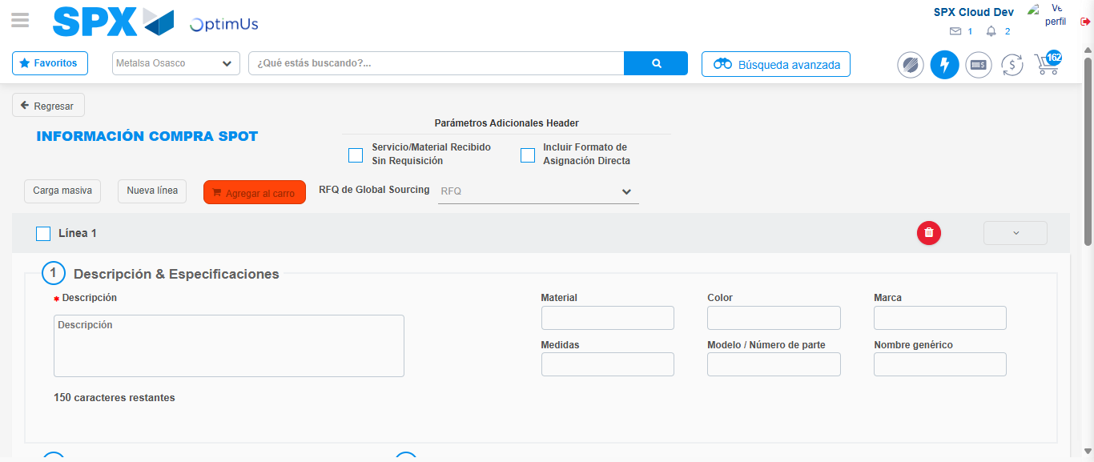Image file-name: QC_Testing-tc003_SPX_Dev5_Crear_Requisicion_Spot_Tipo_Cobro_CC_Urgent-1785961198642

Image file-name: QC_Testing-tc003_SPX_Dev5_Crear_Requisicion_Spot_Tipo_Cobro_CC_Urgent-1785961198809

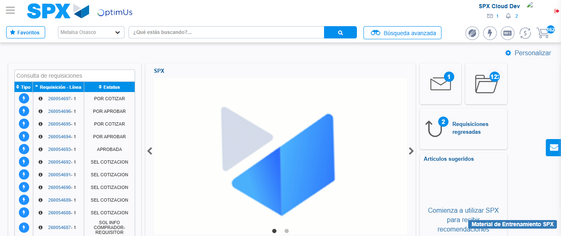Image file-name: QC_Testing-tc003_SPX_Dev5_Crear_Requisicion_Spot_Tipo_Cobro_CC_Urgent-1785961219873

Step 8 - Log Out : Log Out SPX
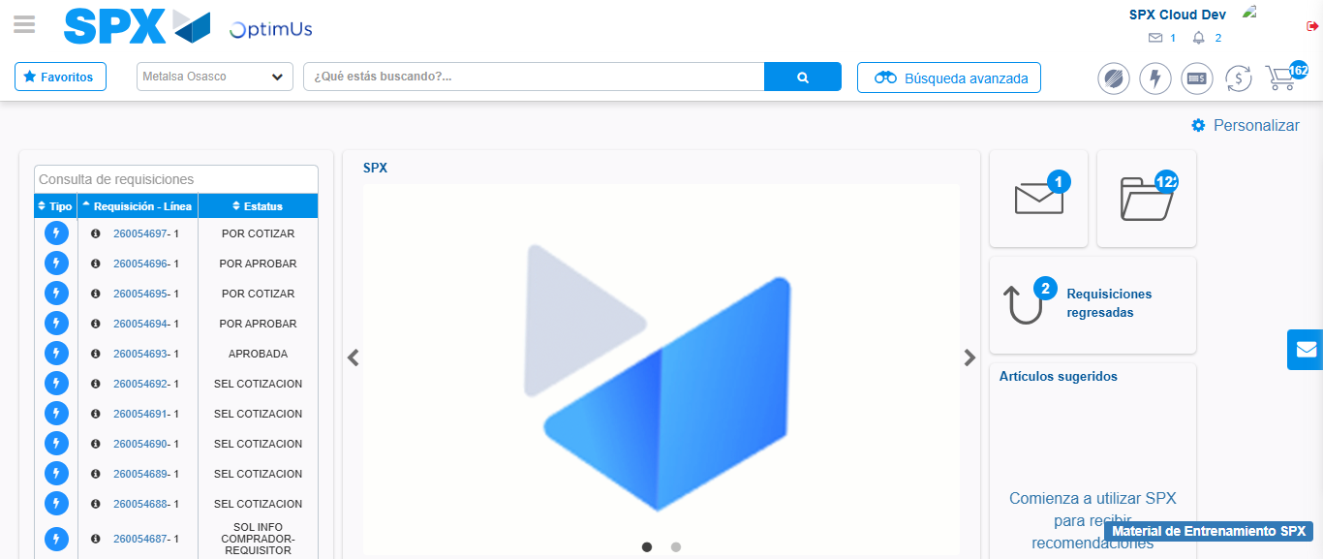Image file-name: QC_Testing-tc003_SPX_Dev5_Crear_Requisicion_Spot_Tipo_Cobro_CC_Urgent-1785961220165

